



SMDM GRADED PROJECT

A PROJECT REPORT
Submitted by

BALAJI S (PGP-DSBA-JUNE 2023 TO JUNE2024)

Part 1: PCA:
Problem Statement: The ‘Hair Salon.csv’ dataset contains various variables used for the context of Market Segmentation. This case study is based on various parameters of a salon chain of hair products. You are expected to do a Principal Component Analysis for this case study according to the instructions given in the rubric. Kindly refer to the PCA_Data_Dictionary.jpg file for the Data Dictionary of the Dataset.
Note: This particular dataset contains the target variable satisfaction as well. Please drop this variable before doing a Principal Component Analysis.

- PCA: Perform Exploratory Data Analysis [univariate and multivariate analysis to be performed]. The inferences drawn from this should be properly documented.

Reading the data and performing basic checks like checking head, info, summary, nulls, duplicates, etc.

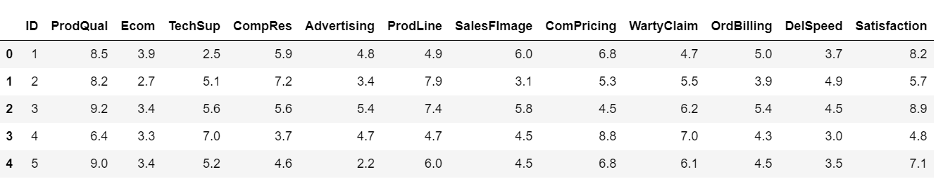

HEAD

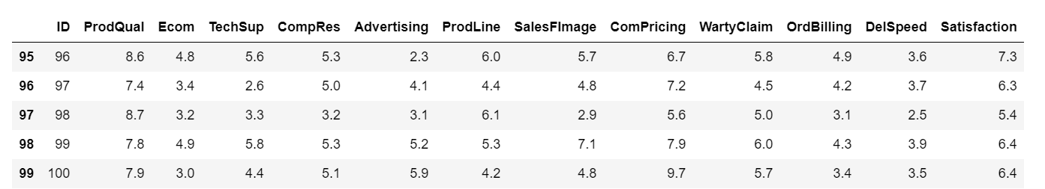

TAIL

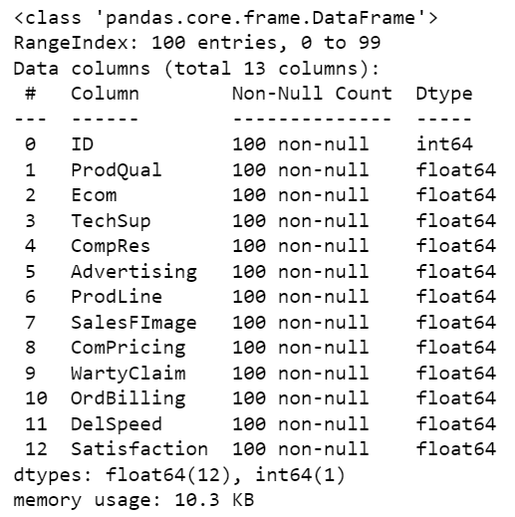
INFORMATION ABOUT THE DATASET

CHECKING THE DUPLICATE AND NULL VALUES
It shows that there is no null and duplicate values in the dataset.

PERFORMING EDA FOR THE GIVEN DATASET:
UNIVAIRENT ANALYSIS:
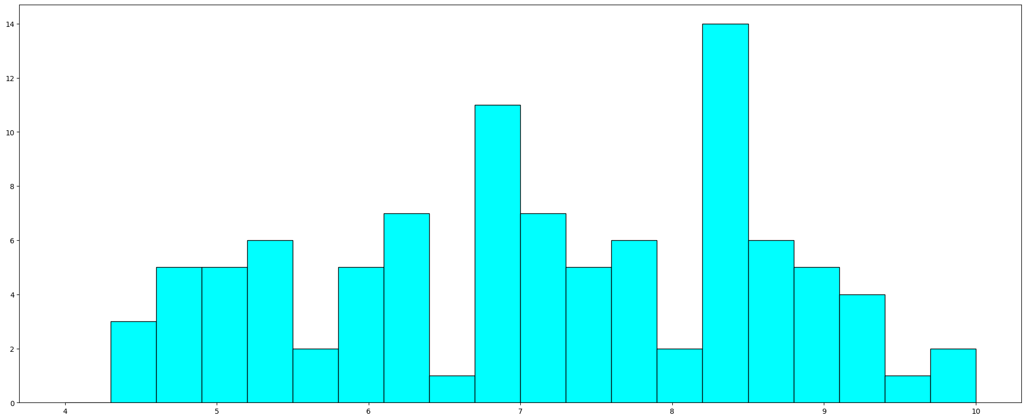
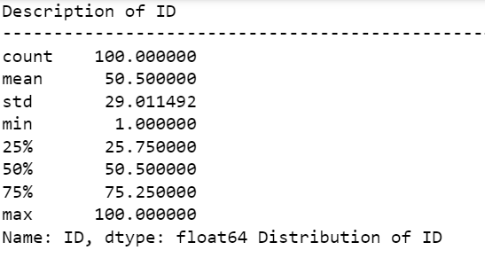
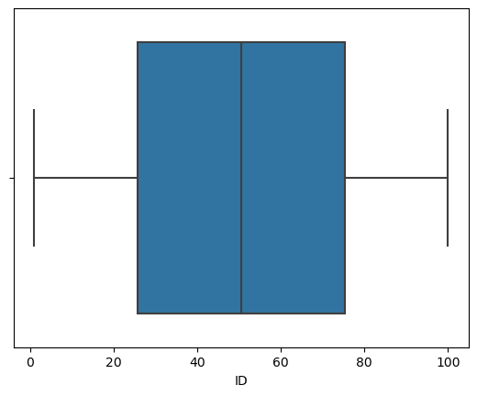

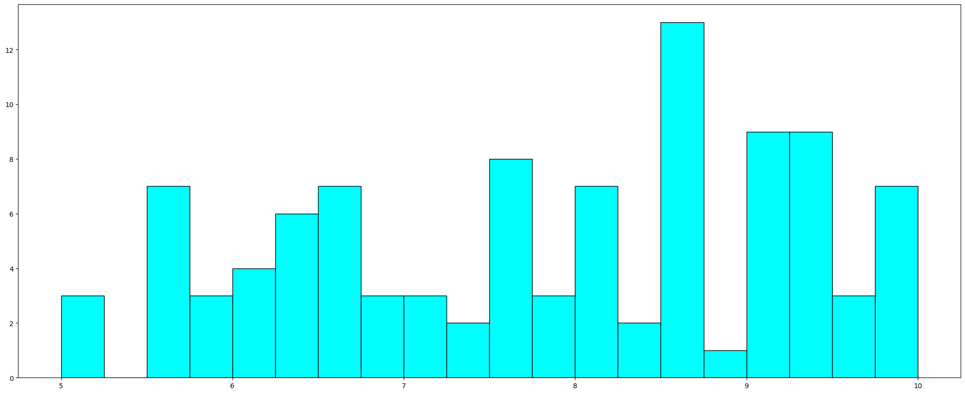

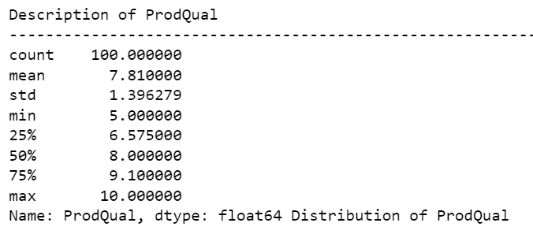
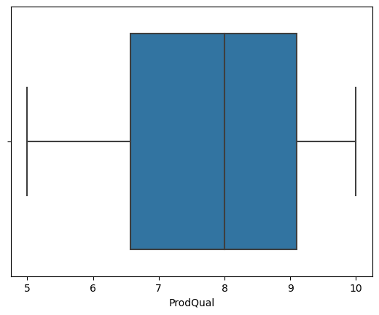

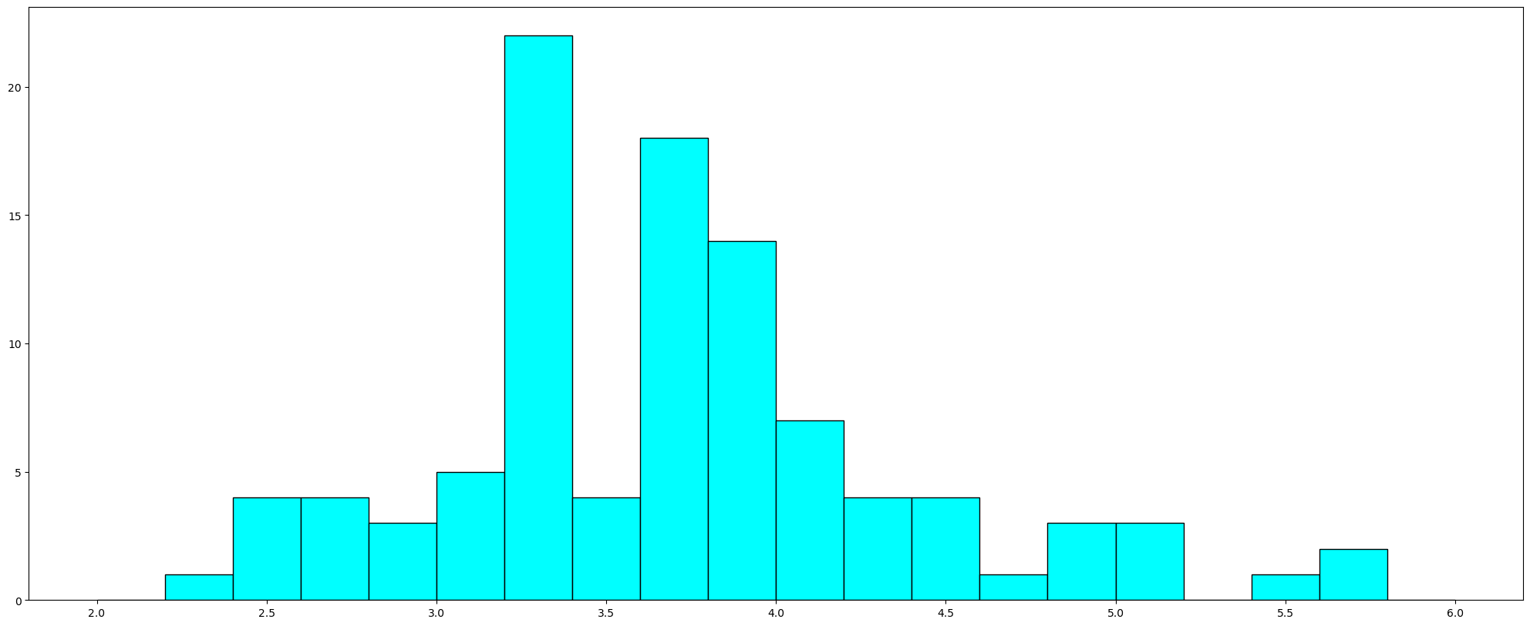

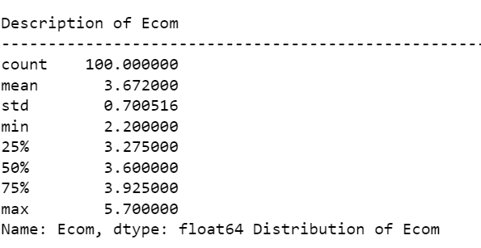

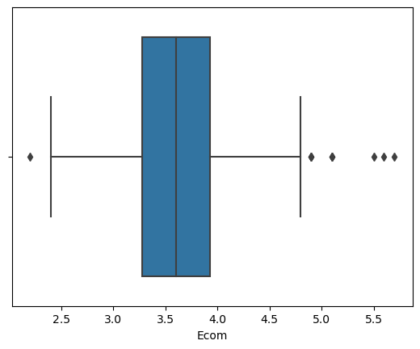

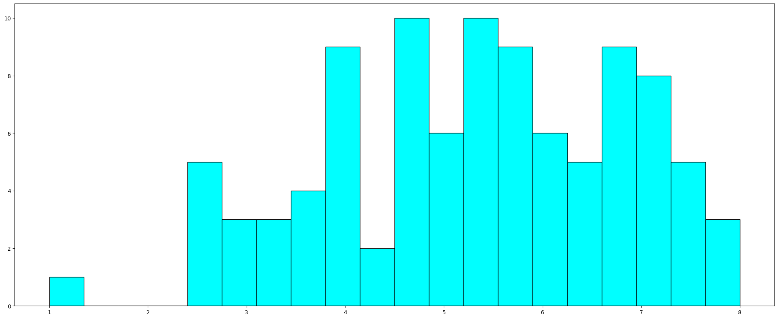

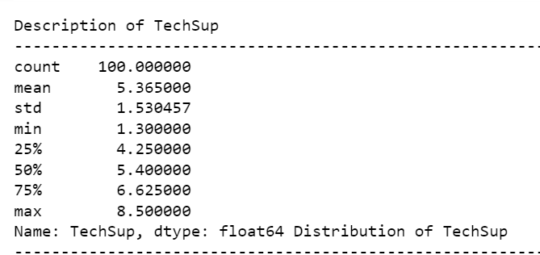
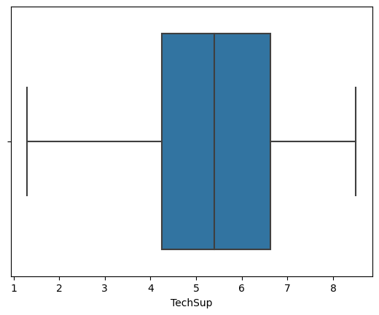

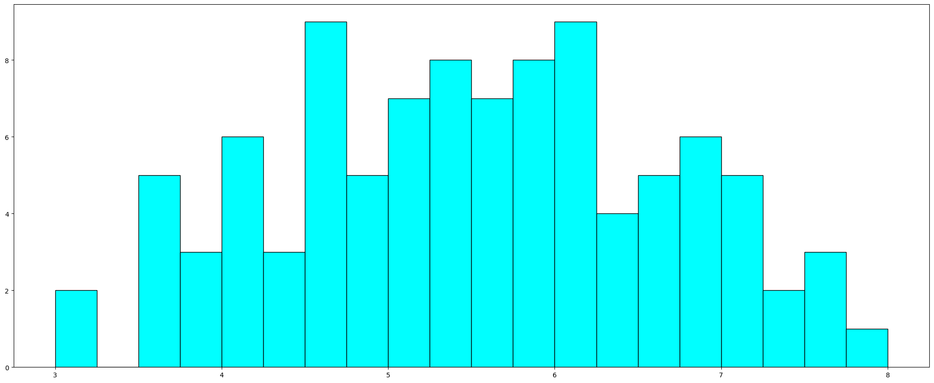
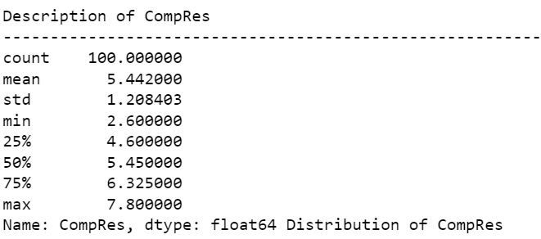

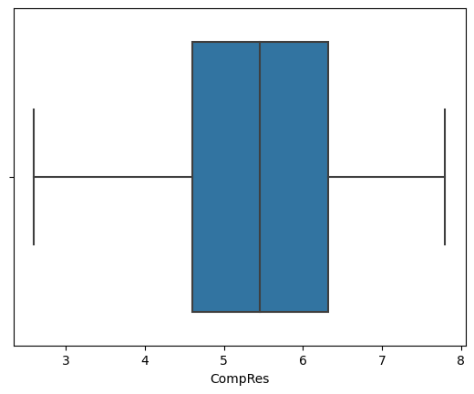

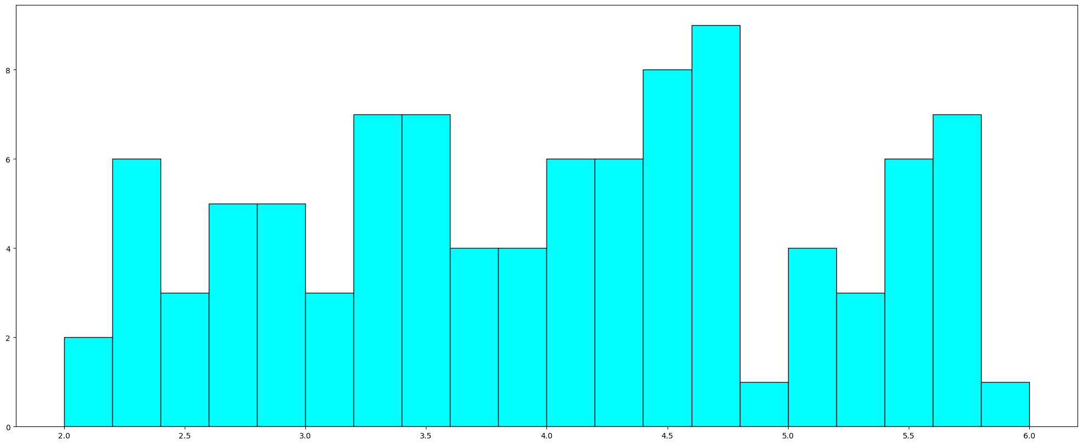
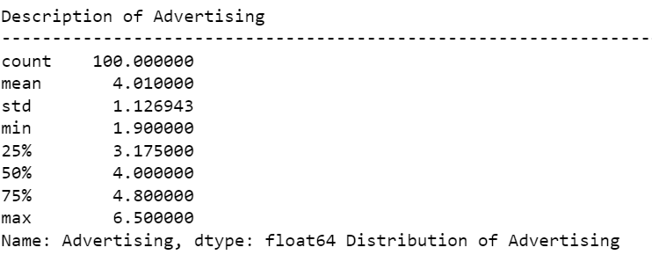

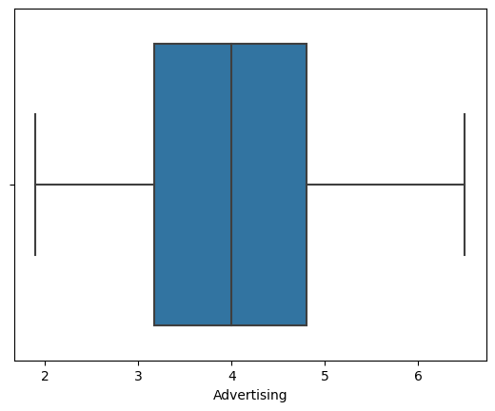

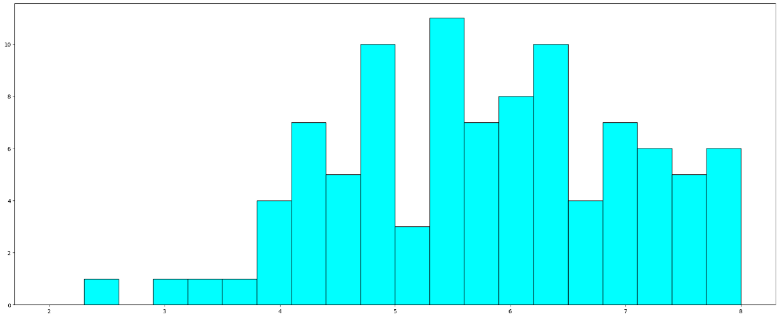

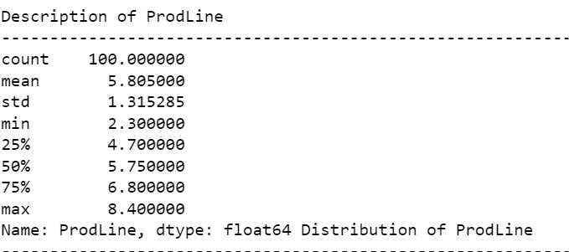
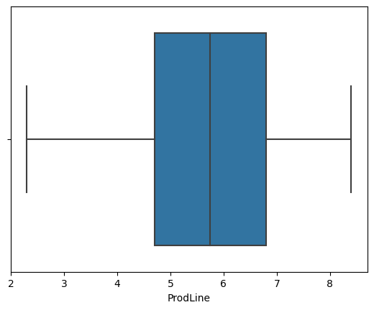

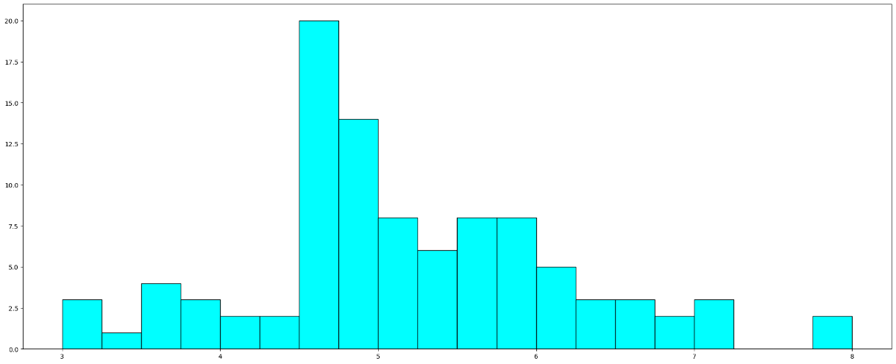

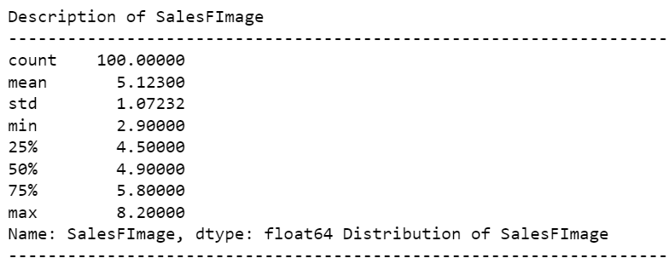

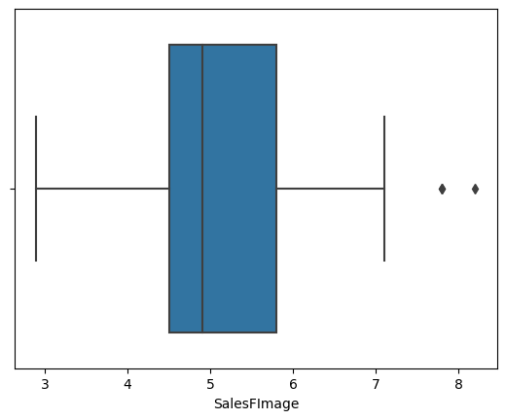

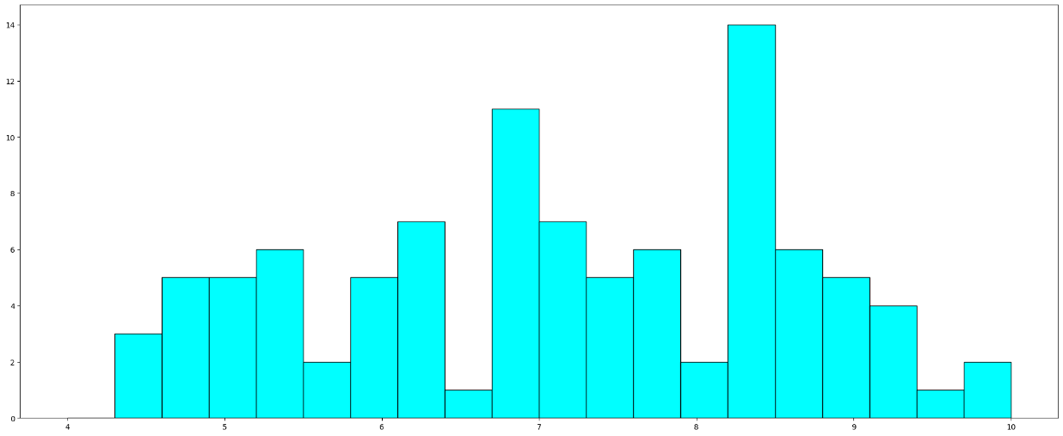
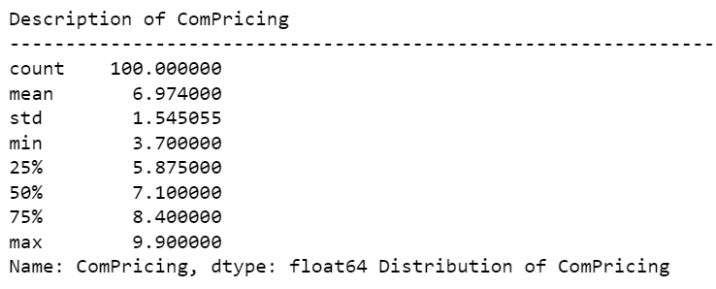

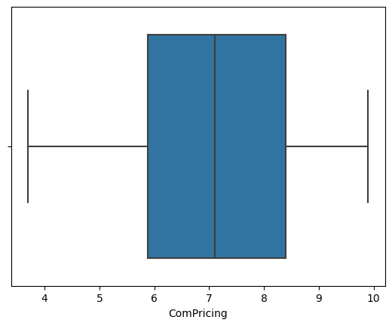

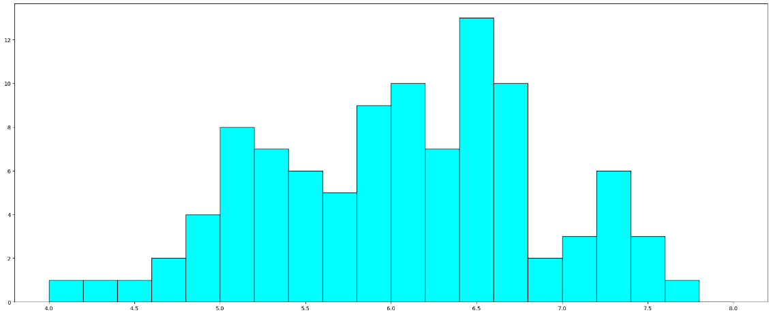

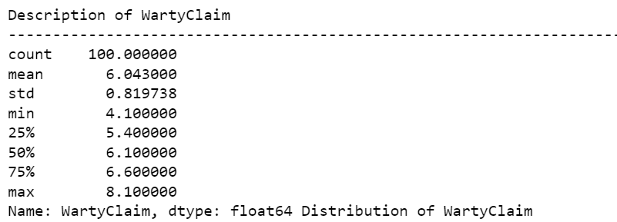
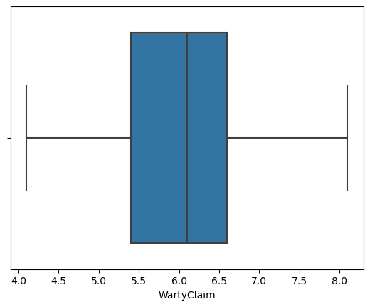

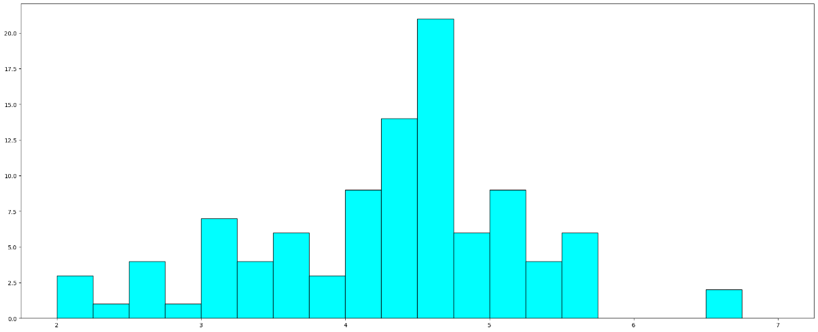

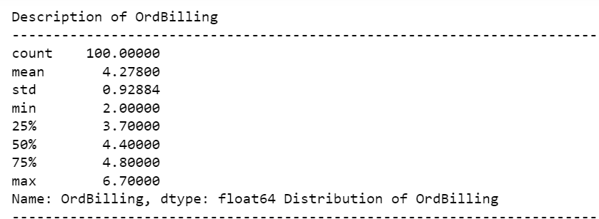
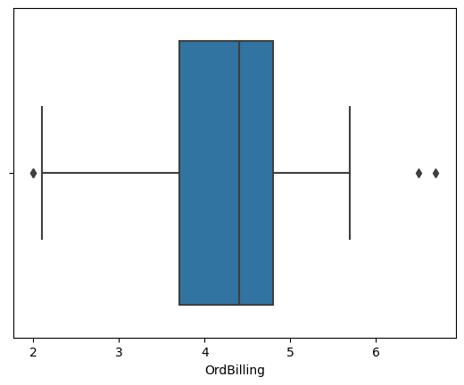

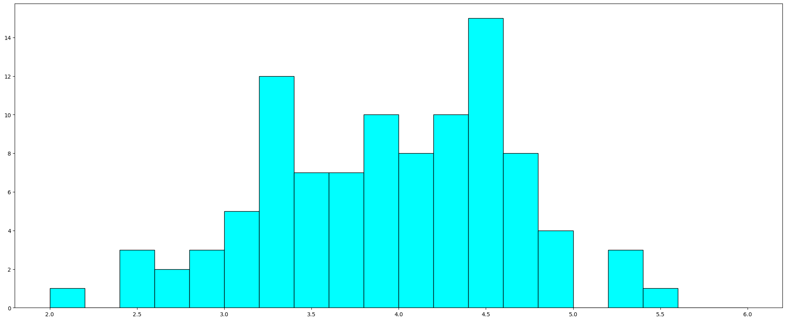
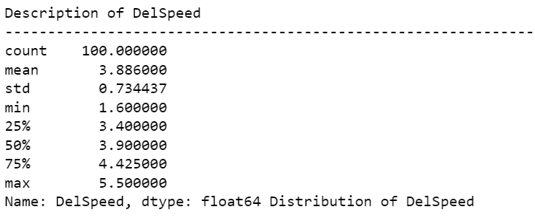
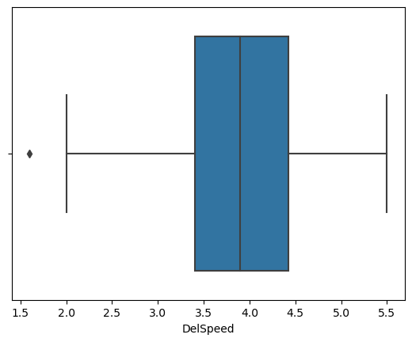

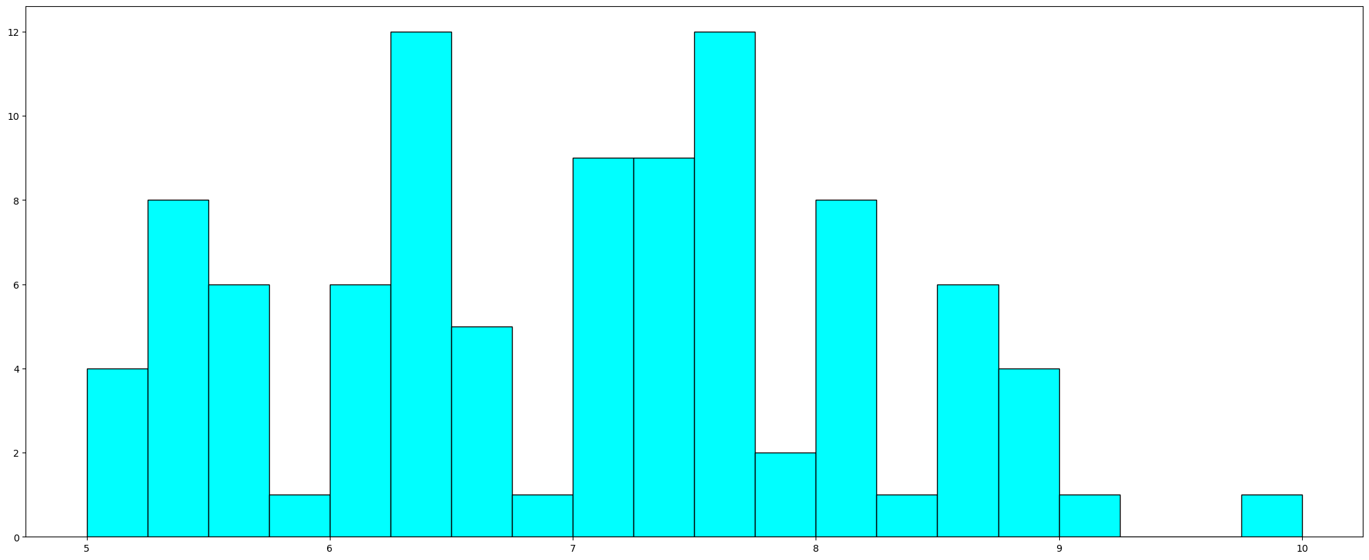

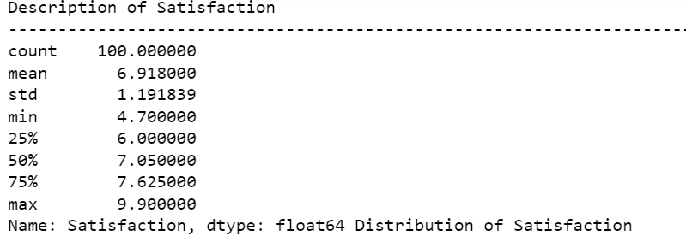
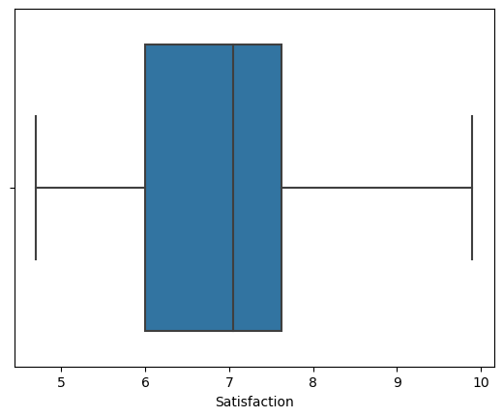

MULTI-VARIENT ANALYSIS:
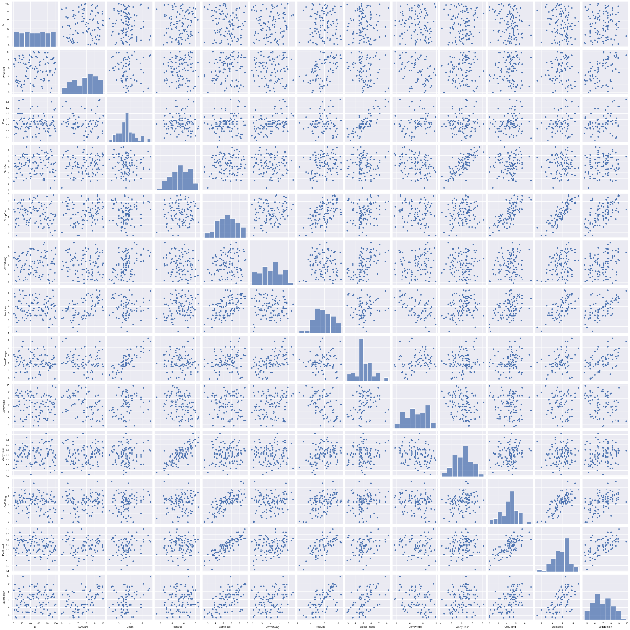

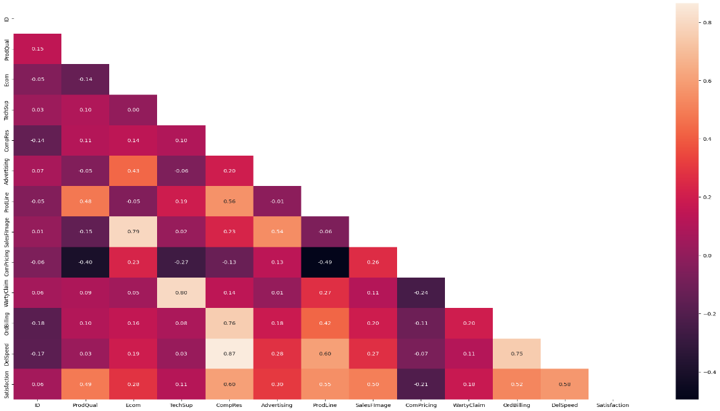

HEATMAP FOR CORRELATION
2.Scale the variables and write the inference for using the type of scaling function for this case study.

Here we use Standardscalar

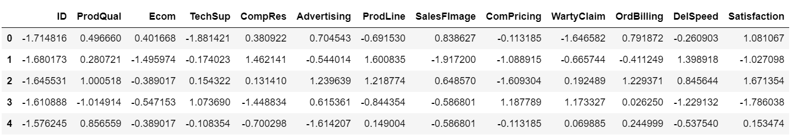

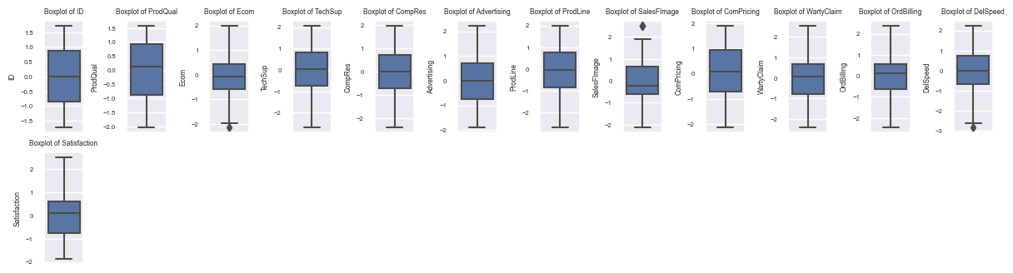

BOXPLOT OF FEATUERD COLUMN
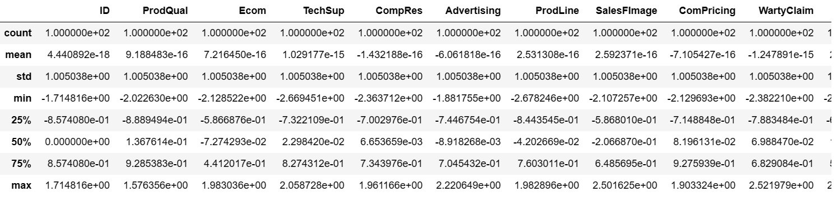

DESCRIBING THE SCALED DATA
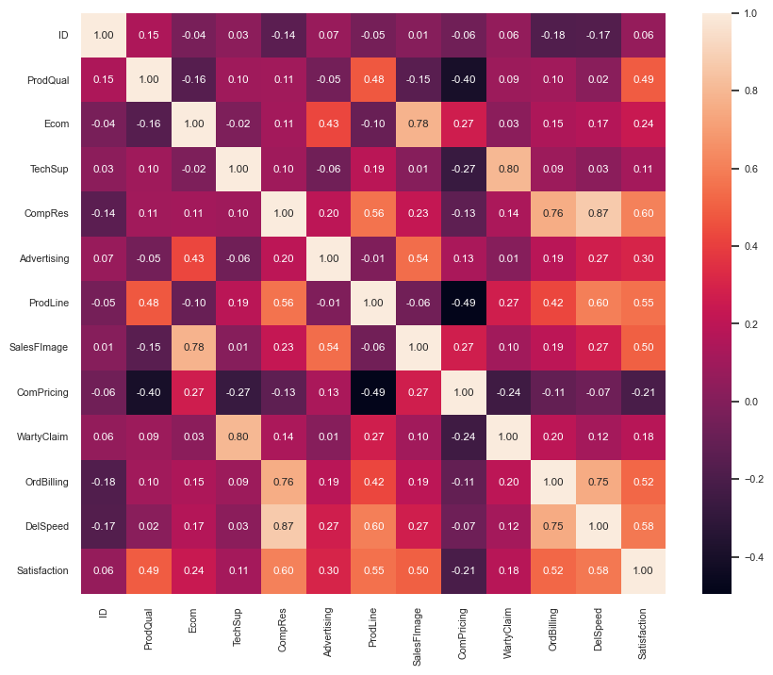
HEATMAP OF CORRELATION OF THE SCALED DATA

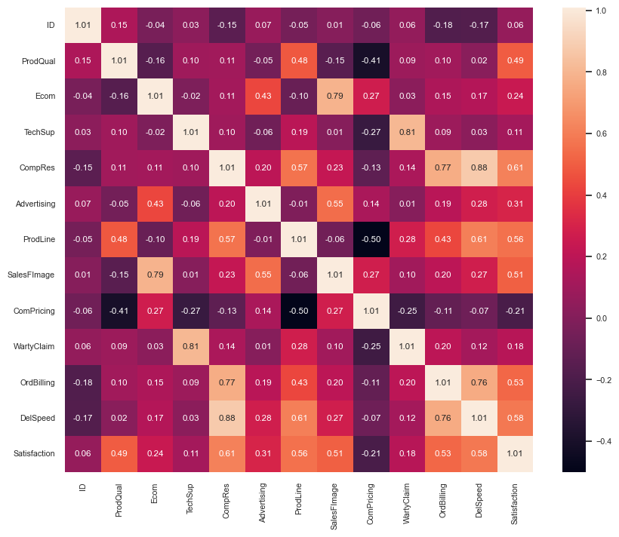
HEATMAP OF COVARIANCE OF THE SCALED DATA

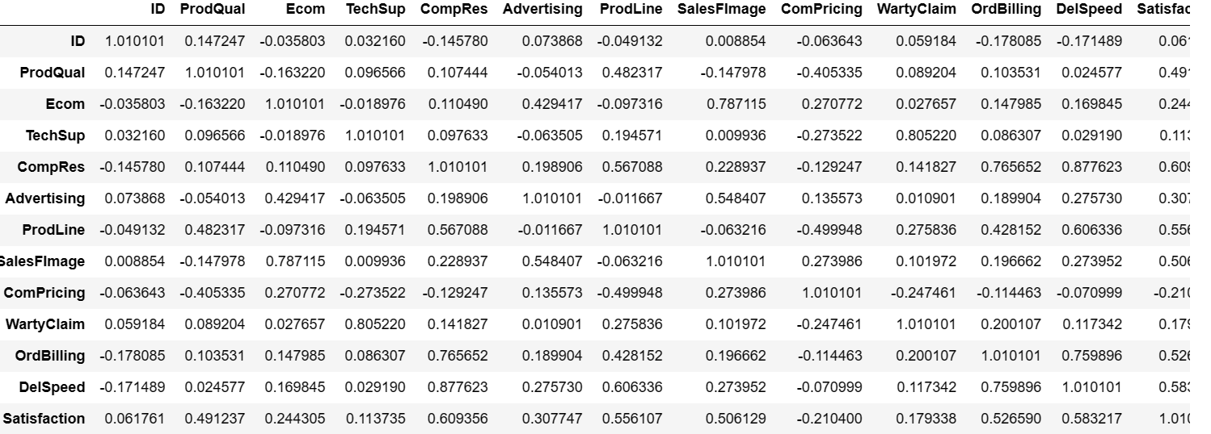

COVARIANCE OF THE SCALED DATA

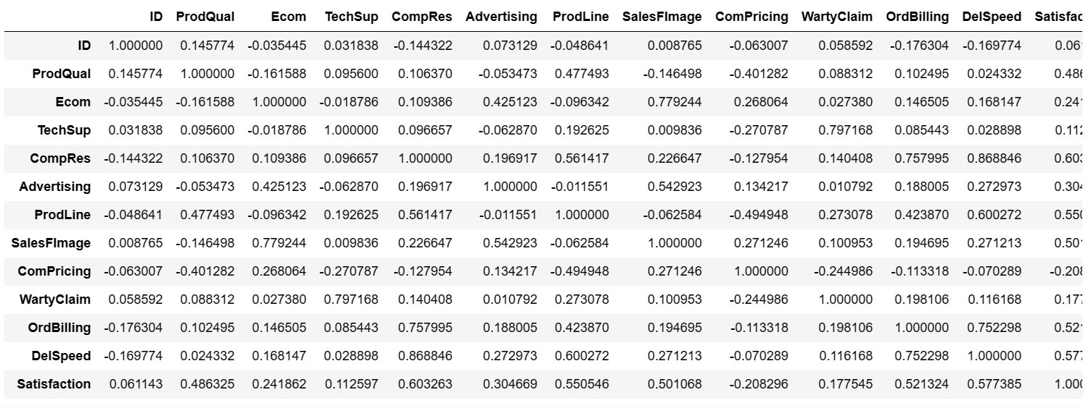
CORRELATION OF THE SCALED DATA

CHI-SQUARE VALUE METHOD:
Confirm the statistical significance of correlations
- H0: Correlations are not significant, H1: There are significant correlations
- Reject H0 if p-value < 0.05
CHI-SQUARE VALUE: 
KMO-MODEL
Confirm the adequacy of sample size.
Note: Above 0.7 is good, below 0.5 is not acceptable
KMO-MODEL: 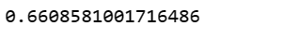

3.Check the dataset for outliers before and after scaling. Draw your inferences from this exercise.

DATASETS BEFORE TREATING OUTLIERS(BEFORE SCALING)
Here we see that there are outliers that need to be treated as they may cause some error data during the calculation

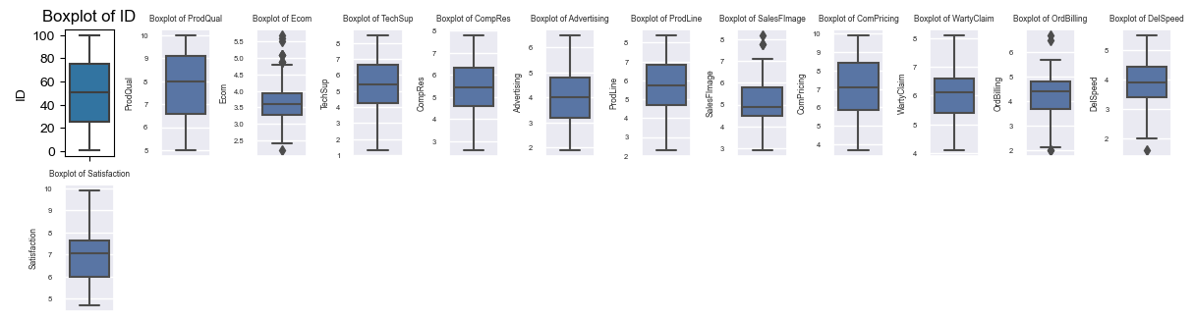

DATASETS AFTER TREATING OUTLIERS: ( AFTER SCALING)
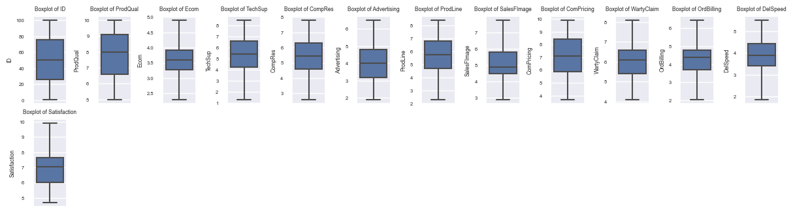

4.Build the covariance matrix, eigenvalues and eigenvector.

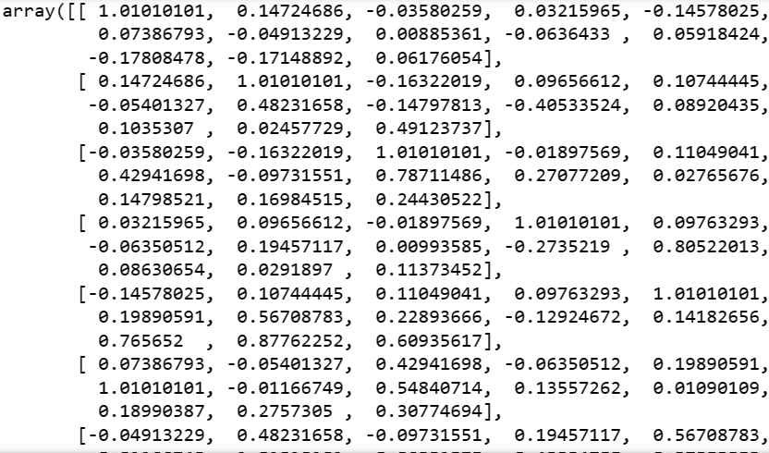
COVARIANCE MATRIX
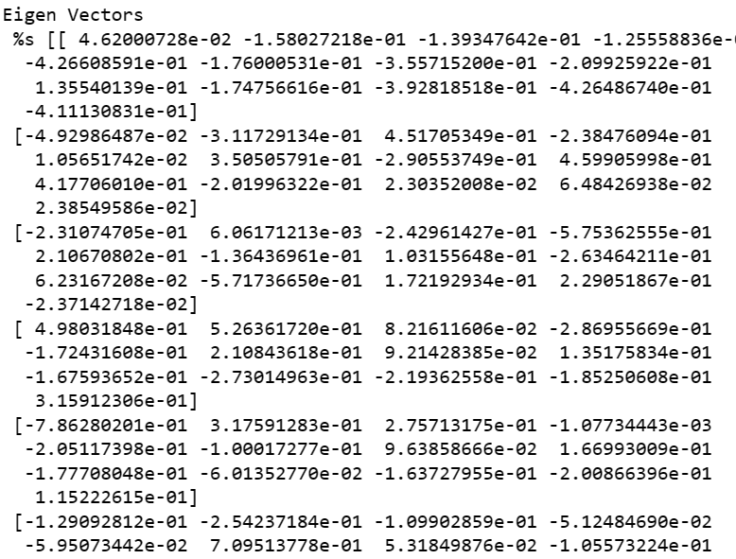

EIGEN VECTORS

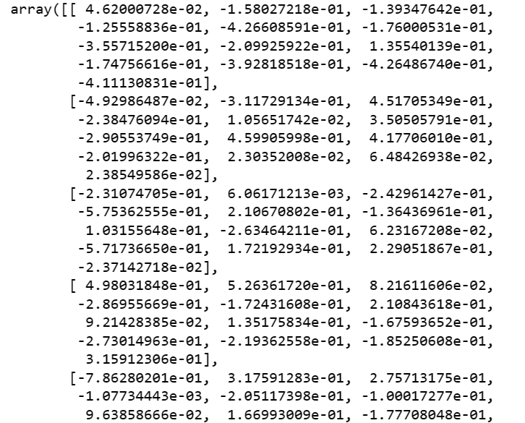

EIGEN VALUES
5.Write the explicit form of the first PC (in terms of Eigen Vectors).

6. Discuss the cumulative values of the eigenvalues. How does it help you to decide on the optimum number of principal components? What do the eigenvectors indicate? Perform PCA and export the data of the Principal Component scores into a data frame.

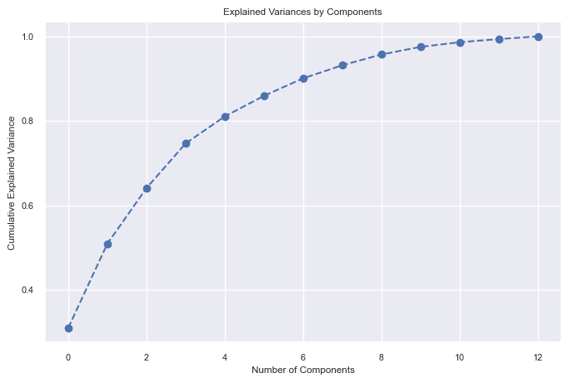

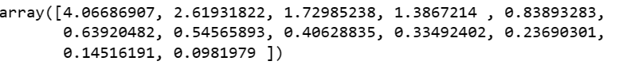

EXPLAINED VARIANCE

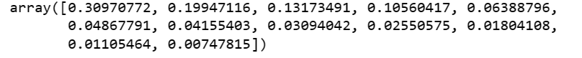

EXPLAINED VARIANCE RATIO

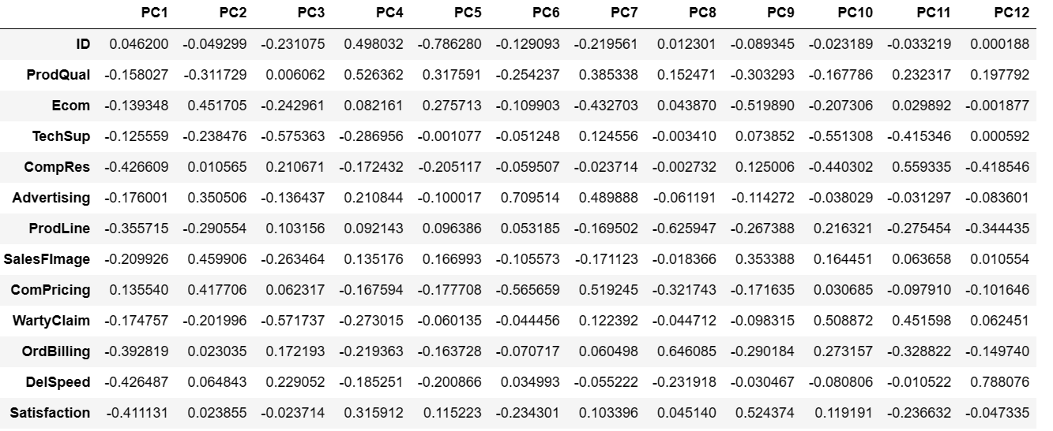
EXTRACTED LOADINGS OF THE DATASCALED
5.Mention the business implication of using the Principal Component Analysis for this case study.
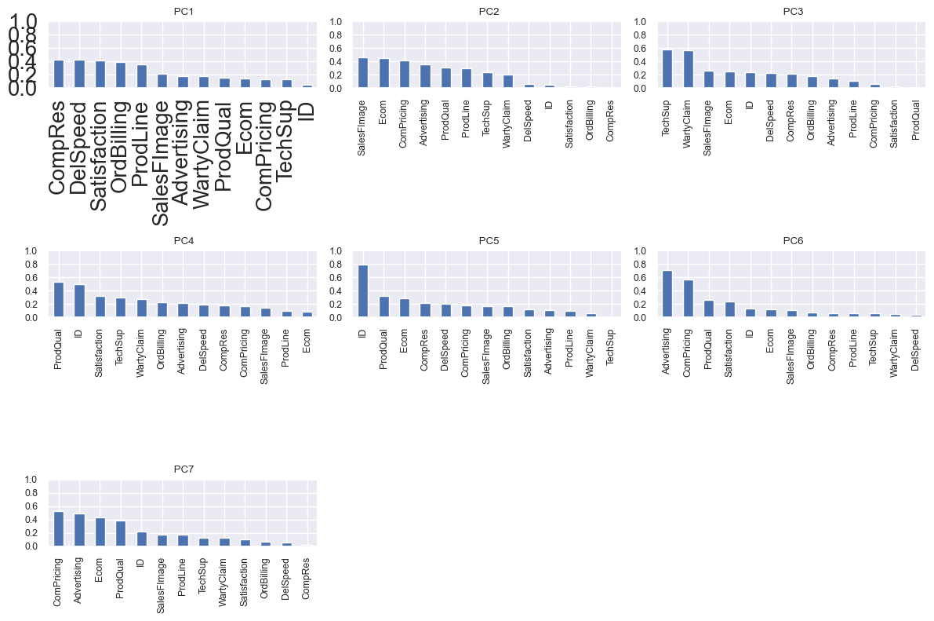

PC1 has compres ,delspeed satisfaction,ord billing,prod line equal and high followed by salesfimage,advertising, warty claim,prod qual,Ecom,comp pricing,tech sup features almost equal.
PC2 has all the features in decreasing trend starting from salefimage as the highest and compres as the lowest...
In PC 3 tech sup and waranty claim features have higher values up to 0.6 and remaining all features are in a decreasing trend starting from salesfimage as 0.25 ending with prod quality as the lowest

Pc 4 prod quality has the highest value upto 0.55 after that all features are seems to be in decreasing trend from satisfaction of 0.3 to Ecom as the lowest of 0.1
Pc 5 prod quality has the highest value of 0.3 to the waranty claim as the lowest of 0.5
Pc 6 advertising has the highest value of 0.7 to the delspeed having the lowest of 0.2 .
Pc 7 also all the features are in the decreasing trend starting from comprising with value of 0.5 to the lowest of compres with value of 0.1

As a conclusion pc1 is expaling the most variance with almost equal values in two sets..

Problem Statement: The dataset given is about the Health and economic conditions in different States of a country. The Group States based on how similar their situation is, so as to provide these groups to the government so that appropriate measures can be taken to escalate their Health and Economic conditions
Data Dictionary
1 States: names of States
2. Health indeces1: A composite index rolls several related measures (indicators) into a single score that provides a summary of how the health system is performing in the State.
3. Health indeces2: A composite index rolls several related measures (indicators) into a single score that provides a summary of how the health system is performing in certain areas of the States
4. Per capita income-Per capita income (PCI) measures the average income earned per person in a given area (city, region, country, etc.) in a specified year. It is calculated by dividing the area's total income by its total population
5. GDP- GDP provides an economic snapshot of a country state, used to estimate the size of an economy and growth rate.

2.1. Read the data and do exploratory data analysis. Describe the data briefly. (Check the null values, Data types, shape, EDA, etc.)

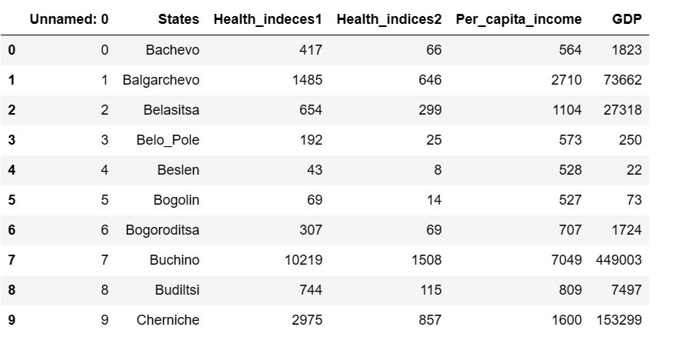
HEAD VALUES

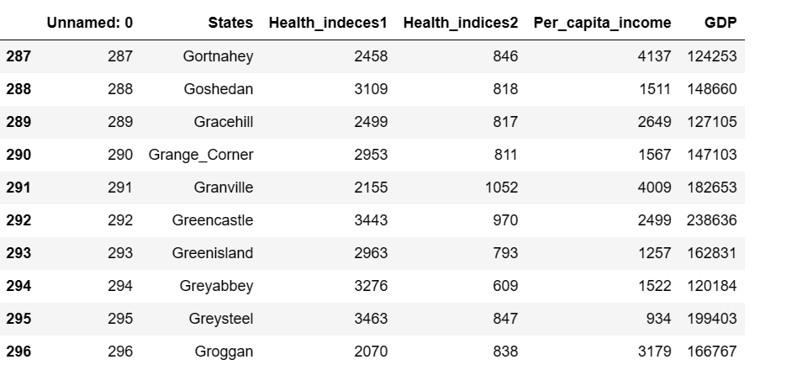

TAIL VALUES

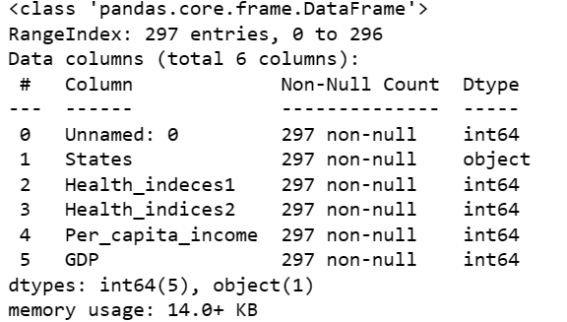
BASIC INFORMATION OF THE DATASET

There are two variables "Unnamed O' and States that signify only the id in the dataset and are not required in the clustering process. Hence, these can be dropped. After dropping these variables

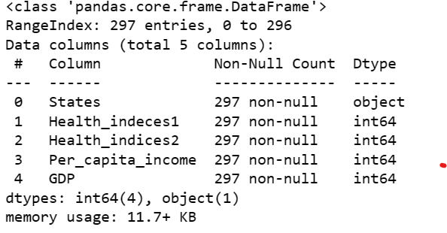
- There are 4 variables and 297 records.
- No missing record based on initial analysis.
- All the variables are integer-type variables.
- Shape of the Dataset: (297, 4)
- This shows the total number of rows = 297 and the total number of columns = 4.

UNIVARIATE -ANALYSIS:

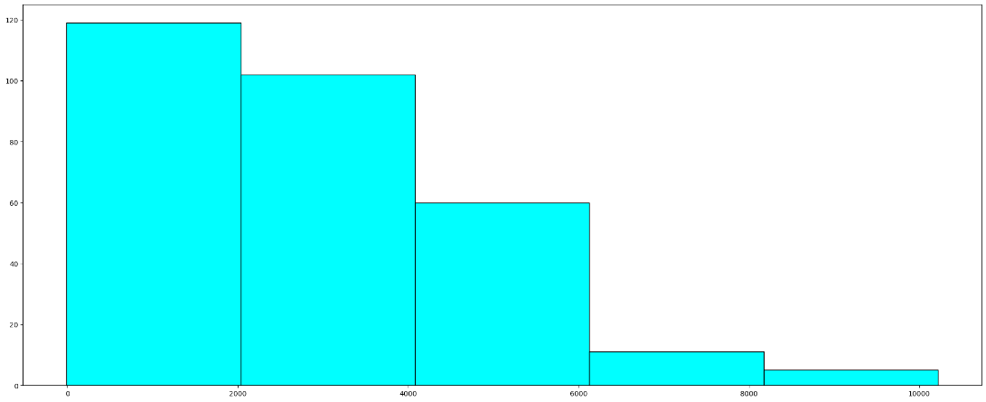

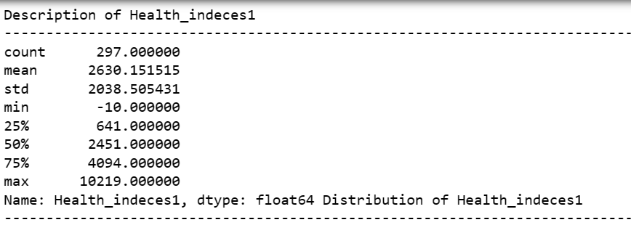

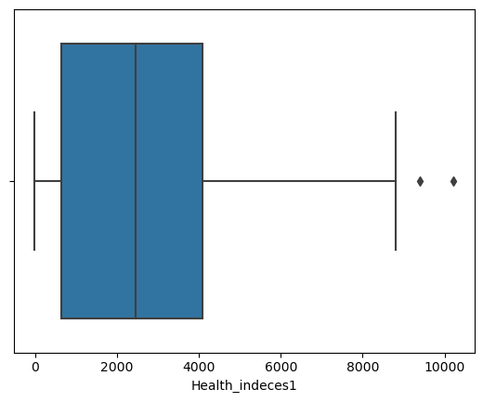

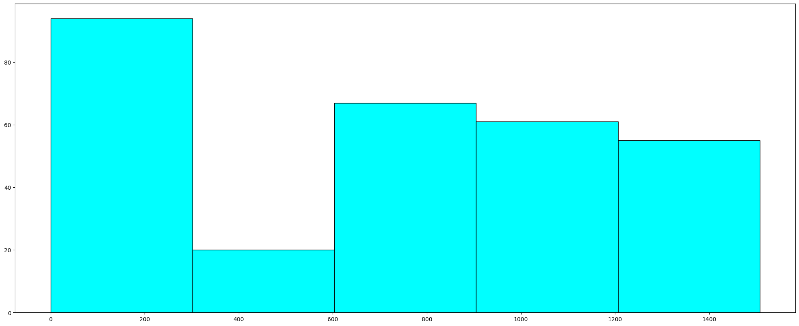

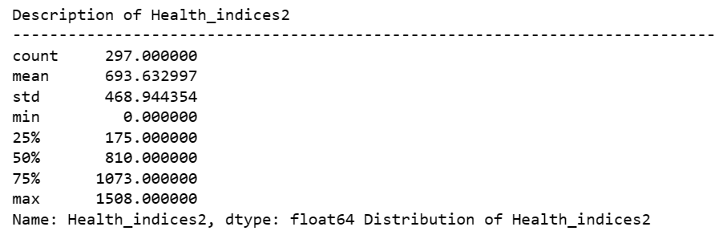

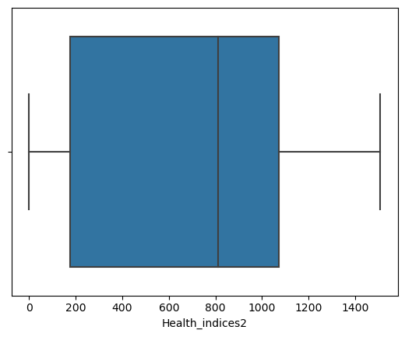

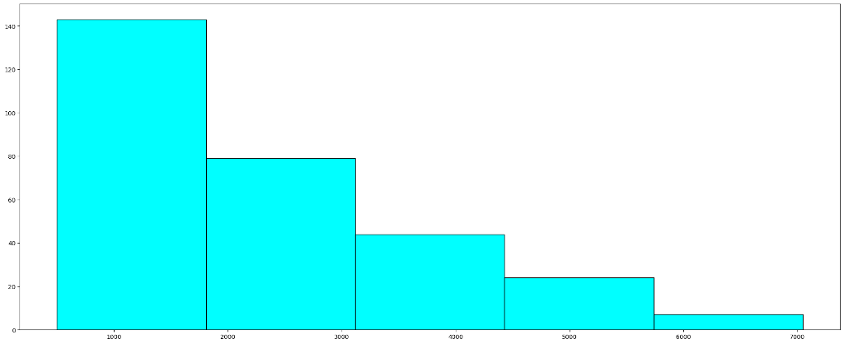

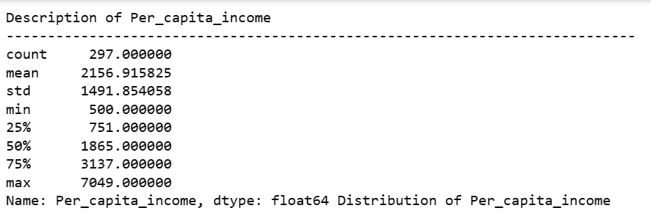

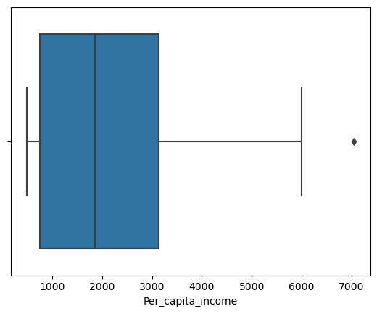

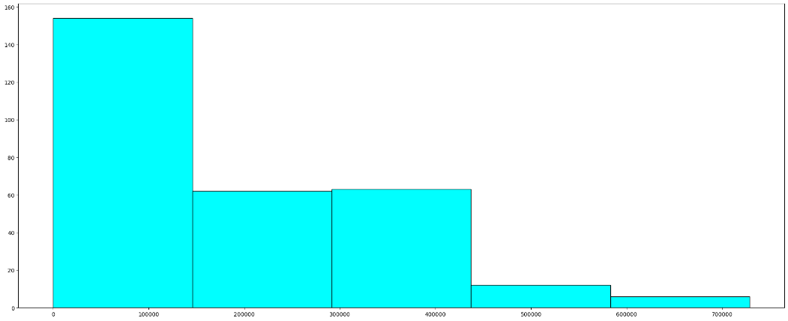
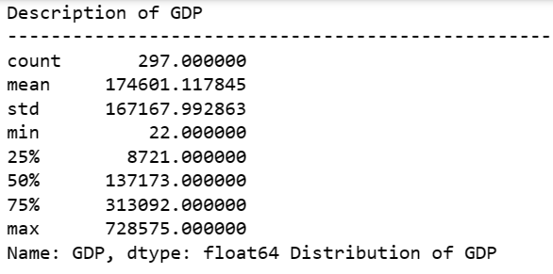

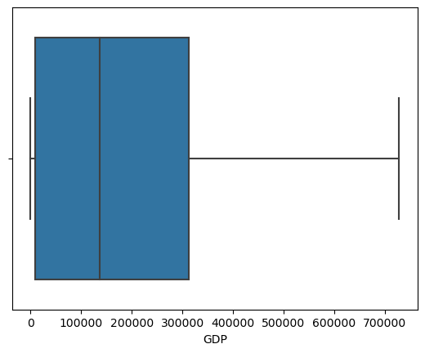

MULTI-VAIRENT ANALYSIS:
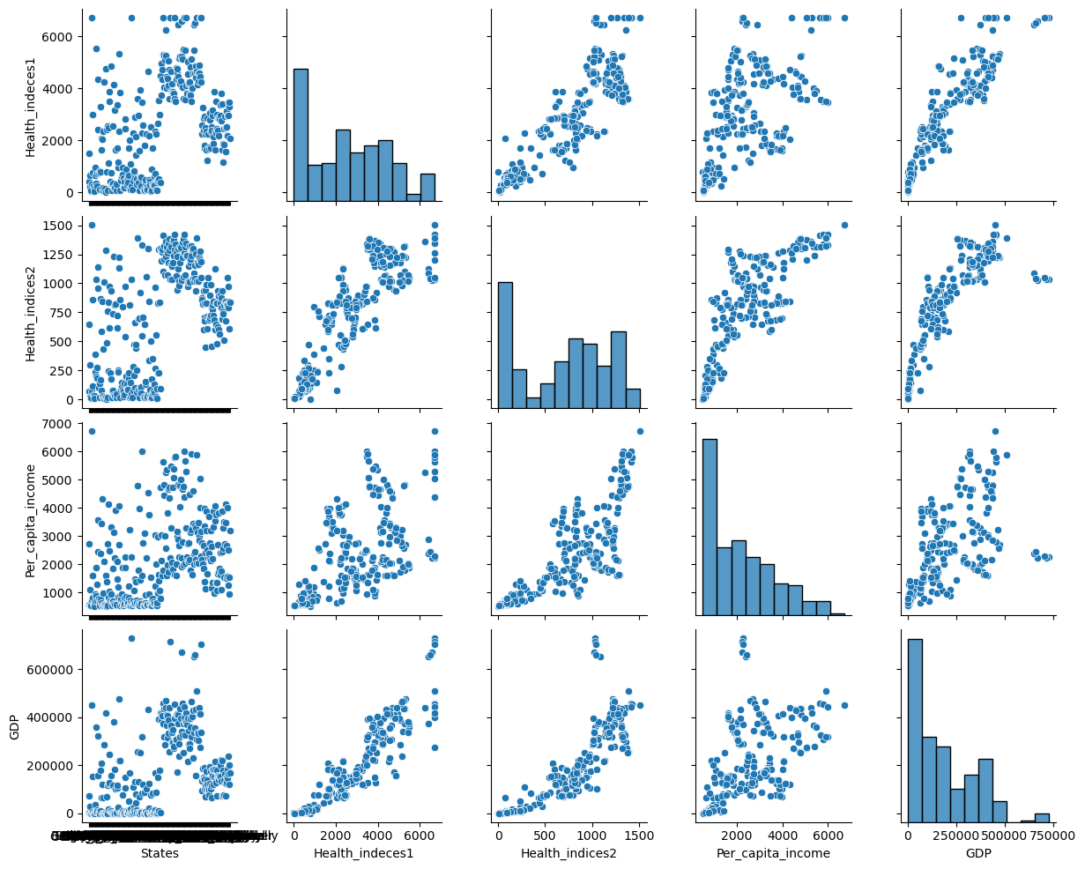
COVARIANCE MATRIX:

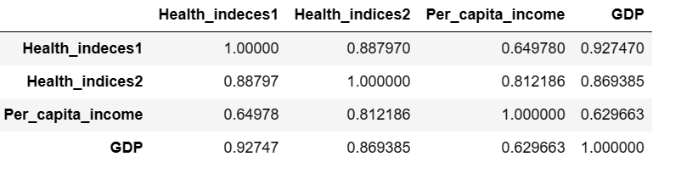
CORRELATED MATRIX:
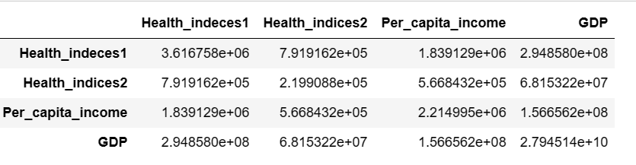

HEATMAP OF CORRELATED MATRIX:
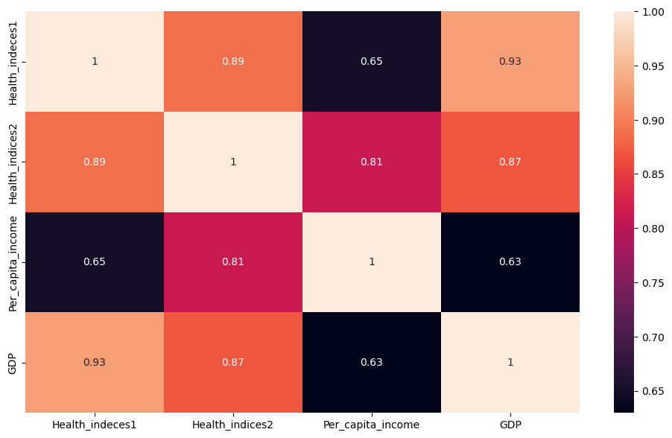

BEFORE TREATING OUTLIERS

No. of outliers in Health indeces1: 2
No. of outliers in Per capita income: 1
Outlier Treatment- Instead of Imputing which causes data loss we will define a custom function- If for a particular column, the value is greater than the max value, then assign that max value to it. Same logic for the min value as well. This is known as min-max substitution.
AFTER TREATING OUTLIERS:

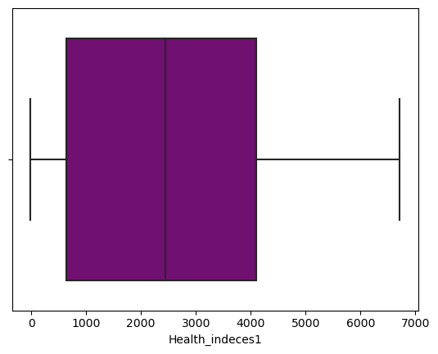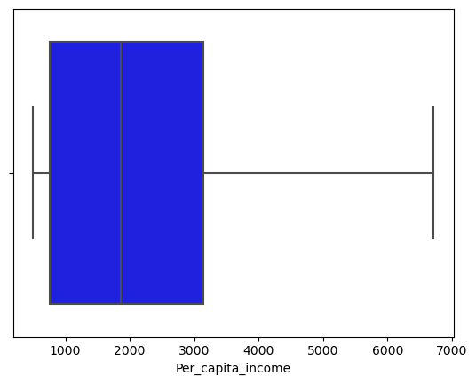

2.2. Do you think scaling is necessary for clustering in this case? Justify
Yes, Scaling is necessary as Clustering algorithms such as K-means do need feature scaling before they are fed to the algorithm. Since clustering techniques use Euclidean Distance, it will be wise to scale the data consisting of attributes with different units of measurements
The above dataset consists of data with different units of measurement also known as weights, thus scaling them will form a common space and data will be from a relative range

We will use z-score scaling here, in which means and standard deviation1

2.3. Apply hierarchical clustering to scaled data. Identify the number of optimum clusters using a Dendrogram and briefly describe them.
There are different methods of clustering, in this dataset we will use "Average" and "Ward" linkage methods. Average Linkage-
In this method, the distance between each pair of observations in each cluster is added up and divided by the number of pairs to get an average inter-cluster distance.
Average-Linkage and complete linkage are the two most popular distance metrics in hierarchical clustering

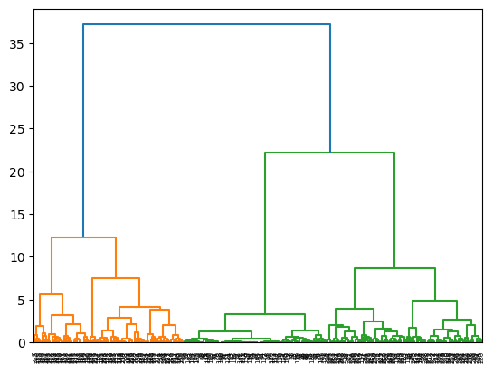

To make it clear we use truncate mode
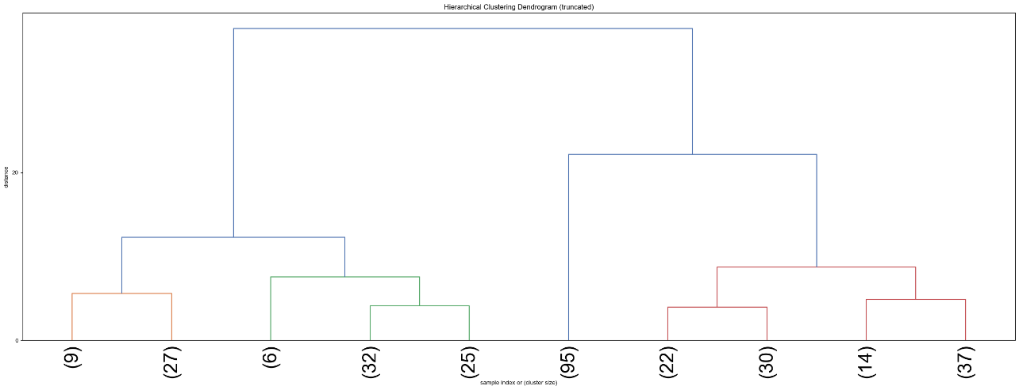

Ward Linkage-
In this method, the linkage function describing the distance between two clusters is computed as the increase in the "error sum of squares" (ESS) after fusing two clusters into a single cluster. Ward's method chooses the successive steps in order to minimize the increase in ESS at each step.

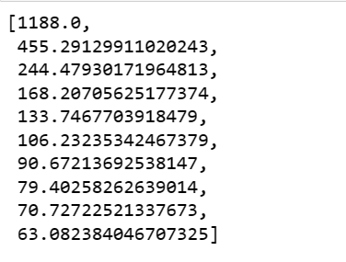-WSS

1.4. Apply K-Means clustering on scaled data and determine optimum clusters. Apply the elbow curve and find the silhouette score.

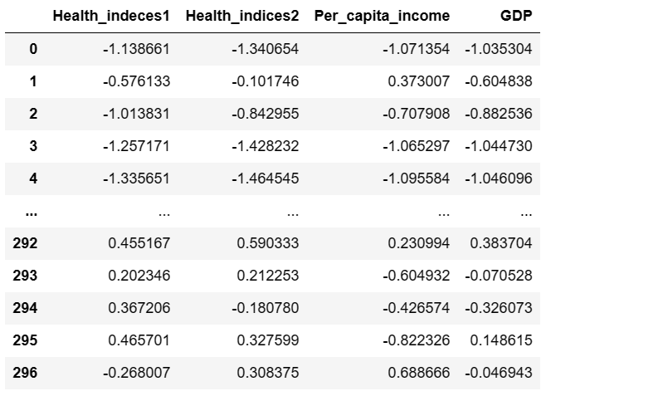
SCALED DATA
K-Mean Clustering. This is an Iterative method of partitioning the data into K-predefined distinct non-overlapping subgroups also known as clusters. In this, Each data point belongs to a single group. In the intra-cluster data points are as similar as possible while the distance between different clusters is as far as possible.
Working steps of an algorithm Specify the number of clusters K

- Initialize centroids by first shuffling the dataset and then randomly selecting K data points for the centroids without replacement
- Keep iterating until there is no change to the centroids, The assignment of data points to clusters isn't changing
- Compute the sum of the squared distance between data points and all centroids.
- Assign each data point to the closest cluster (centroid)

K- means from k=1 to k=10

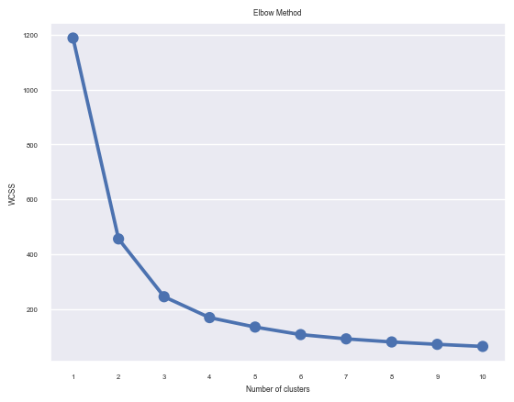
ELBOW METHOD
Silhouette Method- In this we compute the silhouette coefficients for each data point. It is the measure of how close it is to its own cluster rather than other clusters.
Silhouette Score-0.5340151343712788 i.e.,(k=2 to k=10)
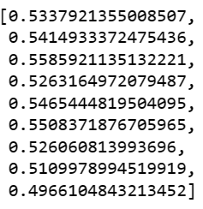

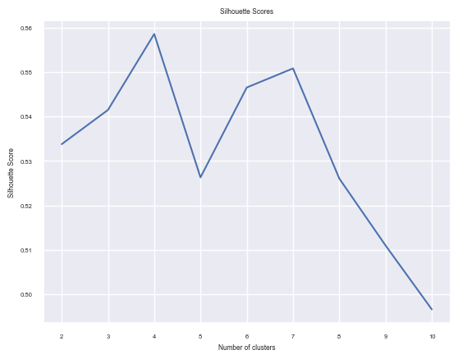

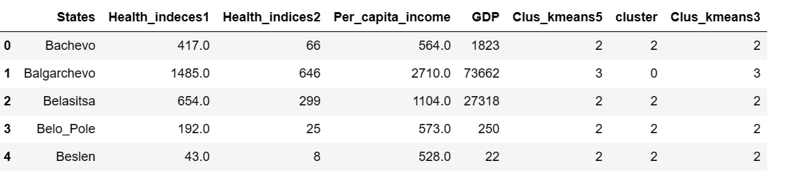

Observations - Based on the above cluster solution, 3 cluster solution seems to be the best fit as it c best fit as it differentiate the 3 clusters as

- High GDP per capita area
- Medium GDP per capita ama
- Low GDP per capita area

1.5. Describe cluster profiles for the clusters defined. Recommend different priority-based actions that need to be taken for different clusters on the bases of their vulnerability situations according to their Economic and Health Conditions

Our main objective was to divide the data into an optimal number of clusters. From both the hierarchal clustering and K-means clustering, we get 3 as the optimal number of clusters

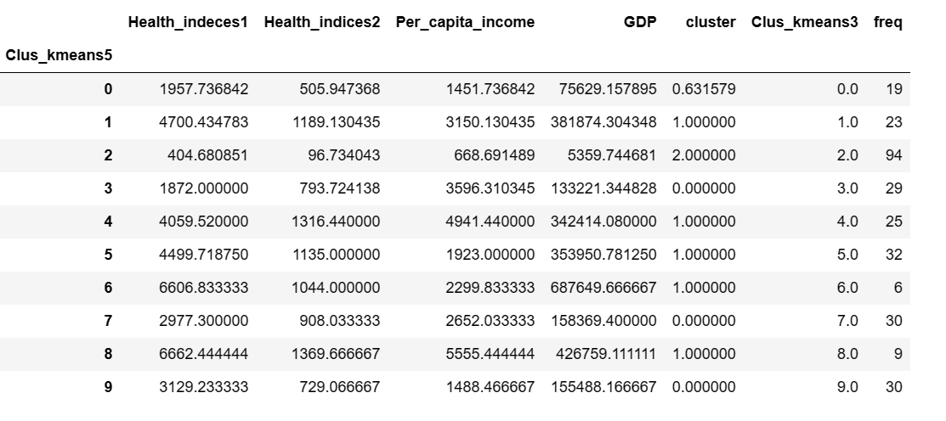

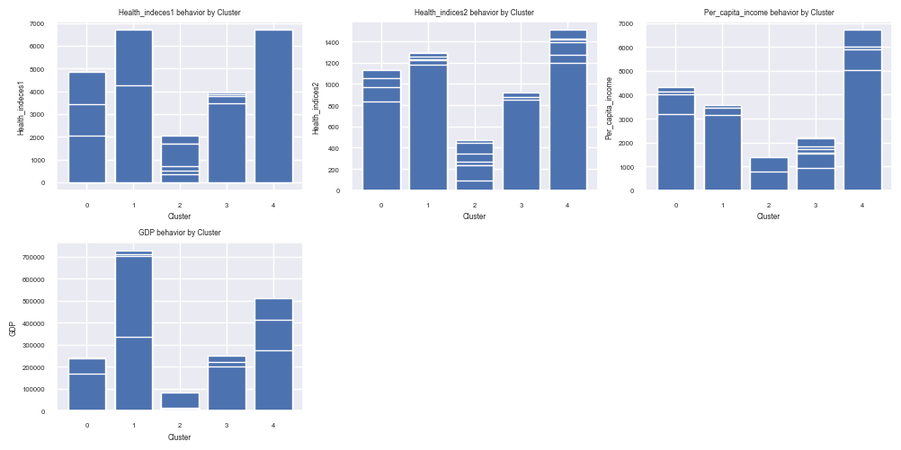

Cluster 1: High GDP per capita Areas:
- These are the areas which have the highest growth rate.
- The health and economic conditions in these areas are excellent Per capita income in these areas is very high.
Cluster 2: Low GDP per capita Areas
- These are the areas which have very low growth rates.
- The health and economic conditions are not good in these areas Per capita income in these areas is very low.
Cluster 3: Medium GDP per capita Areas
- These are the areas which have an average growth rate.
- The health and economic conditions in these areas are adequate-Per capita income in these areas is average.

Recommendations for each cluster profile.
The main features that affect the Health and Economic conditions are workforce and productivity, The Higher these attributes higher the GDP per capita and thus higher the Health and Economic conditions

